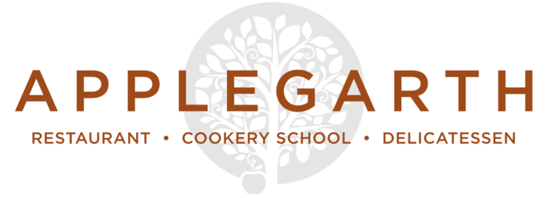

Light Bites

Mixed olives £4 / Salted almonds £4 / Cured meats £7.50

Watercress soup, Capricorn goat’s cheese and apple chutney toastie £8
Steamed Exmouth mussels, white wine, garlic and cream, stone baked baguette £8

Mushrooms on toast, truffle scrambled egg £8.50
Pate of the week, bread & pickles £8

Mains
South coast fish of the day £TBA
Fettuccine, radicchio and Swiss chard, walnut pesto £7.50 / £15
Salmon and sweet potato fish cakes, fennel salad, lemon mayonnaise £8 / £16
BBQ glazed baby back ribs, fries, slaw, baby corn, salad £12 / £19.50

Sunday Roasts
Ask your server for today’s selection of traditional roasted meats all accompanied by roast potatoes,
seasonal vegetables, cauliflower cheese,
homemade Yorkshire Pudding & red wine jus

Sides
Fries £3.50 / Buttered Hampshire potatoes £3.75
Seasonal greens £3.75 / Mixed baby leaf salad £3.75

Desserts

Kingsley honey and Gospel Green cyder jelly, preserved summer currants and garden

grapes, apple sorbet, bee pollen

Dark chocolate, beetroot and rye brownie, Jersey ice cream

Pumpkin pie, seed and nut crust, pine sugar Chantilly

Roasted pear and lime leaf crumble, Jersey cream (or coconut yoghurt, vegan)

(All desserts above are priced at £7)

Ice Cream
Meadow Cottage Jersey cream ice cream with a shot of espresso £4
Scoops of Meadow Cottage ice cream & sorbets (2 scoops £3, 3 scoops £4)

Cheese
3 Cheeses £7.50
5 Cheeses £10.50
Home-made condiments & pickles, seasonal fruit & Fine Cheese Co. crackers
(Gluten free biscuits are available)

PLEASE ADVISE OF ANY ALLERGEN REQUIREMENTS
(gf = gluten free)

Applegarth.co.uk
01428 712777

