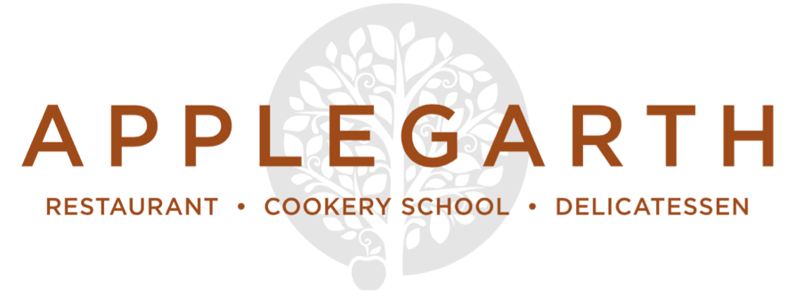

Desserts

Kingsley honey and Gospel Green cyder jelly, preserved summer currants and garden

grapes, apple sorbet, bee pollen

Dark chocolate, beetroot and rye brownie, Jersey ice cream

Pumpkin pie, seed and nut crust, pine sugar Chantilly

Roasted pear and lime leaf crumble, Jersey cream (or coconut yoghurt, vegan)

(All desserts above are priced at £7)

Ice cream

Meadow Cottage Jersey cream ice cream with a shot of espresso £4
Scoops of Meadow Cottage ice cream & sorbets (2 scoops £3, 3 scoops £4)

Cheese

3 Cheeses £7.50
5 Cheeses £10.50
Home-made condiments & pickles, seasonal fruit & Fine Cheese Co. crackers
(Gluten free biscuits are available)

Please make your server aware of any food allergies or special dietary requirements

