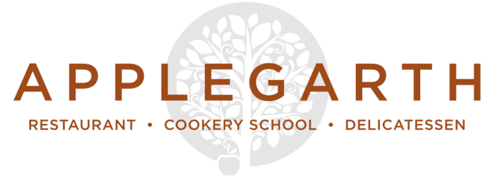

Nibbles

Mixed olives £4 / salted almonds £4 / Cured meats £7.50

Light Bites

Watercress soup, Capricorn goat’s cheese and apple chutney toastie £8
Steamed Exmouth mussels, white wine garlic and cream, stone baked baguette £8

Mushrooms on toast, truffle scrambled egg £8.50
Eggs Benedict £8.50

Pate of the week, bread and pickles (please ask your server for details) £8

Selection of British, Italian and Spanish hams with salami £9

Rare roasted award-winning Longhorn beef sirloin, Balsamic onions £9.50

Salads

Side £3.75 / Starter £7.50 / Main £14.50

Fig, Rachel goat’s cheese and baby leaf salad, blackberry vinaigrette, Parma ham salt

British Carlin peas, spelt and quinoa super grain salad, spiced buttermilk dressing

Bavarian style potatoes, pickled shallot, sweet mustard ketchup

Warm roasted squash, Savoy cabbage, cranberries, cashew nut cream

Glazed fennel, chicory and globe artichoke, anchovy butter

Classic Applegarth Deli Plate

Pork pie, Scotch egg or sausage roll with
Aged Barber’s Vintage Cheddar, Capricorn goat’s cheese, or Colston Bassett stilton
served with a selection of home made pickles, antipasti, salad & rustic bread £14.50

Mains

Fillet of Sea bass, olive tapenade £9

Char-grilled chicken breast, chimichurri £8

West Country lamb rump steak, mint butter £10

Slow roasted red onion and Rosary goat’s cheese quiche £7

Goatober Special

Pulled goat tacos, chipotle yoghurt, salsa fresca, corn tortilla £12

Please make your server aware of any food allergies or special dietary requirements

Classics

Salmon and sweet potato fish cakes, fennel salad, lemon mayonnaise £8 / £16
BBQ glazed baby back ribs, fries, slaw, baby corn, salad £12 / £19.50
6oz award winning Longhorn ribeye steak, fries and chimichurri sauce £19
South coast fish of the day £TBA
Fettuccine, radicchio and Swiss chard, walnut pesto £7.50 / £15

Sides

Fries £3.50 / Buttered Hampshire potatoes £3.75
Seasonal greens £3.75 / mixed baby leaf salad £3.75 / House coleslaw £3.75

Desserts

Kingsley honey and Gospel Green cyder jelly, preserved summer currants and garden

grapes, apple sorbet, bee pollen

Dark chocolate, beetroot and rye brownie, Jersey ice cream

Pumpkin pie, seed and nut crust, pine sugar Chantilly

Roasted pear and lime leaf crumble, Jersey cream (or coconut yoghurt, vegan)

(All desserts above are priced at £7)

Ice cream

Meadow Cottage Jersey cream ice cream with a shot of espresso £4
Scoops of Meadow Cottage ice cream & sorbets (2 scoops £3, 3 scoops £4)

Cheese

3 Cheeses £7.50
5 Cheeses £10.50
Home-made condiments & pickles, seasonal fruit & Fine Cheese Co. crackers
(Gluten free biscuits are available)

Please make your server aware of any food allergies or special dietary requirements

